- Create an S3 bucket and upload some objects to S3.

Step 1. Log in to AWS
1. Open the AWS Management Console in your browser.
2. Sign in with your AWS account credentials.

Step 2. Open the S3 Service**

1. In the AWS console, click **Services**.
2. Under **Storage**, select **S3**.

Step 3. Create a New S3 Bucket**

1. Click **Create bucket**.
2. Enter a **unique bucket name** (e.g., `my-s3-bucket-demo-2025`).
3. Choose an **AWS Region** (e.g., *Asia Pacific (Mumbai) – ap-south-1*).
4. Keep **Block all public access** enabled (recommended).
5. Leave other settings as default.
6. Scroll down and click **Create bucket**.

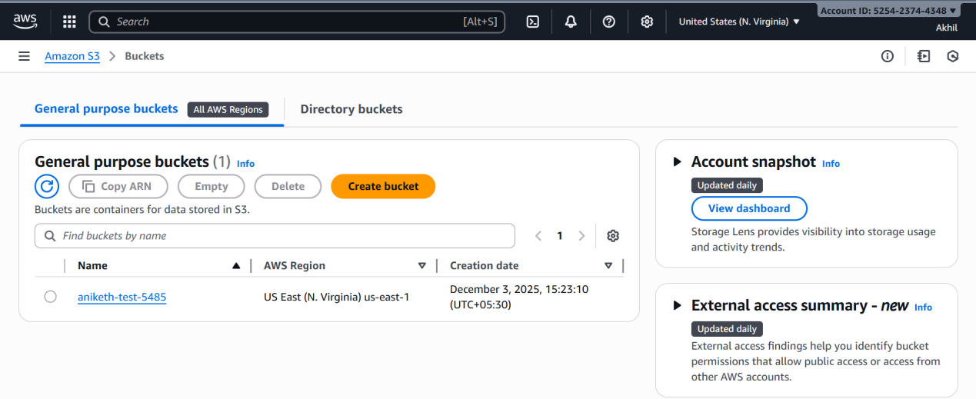

Step 4. Open the Newly Created Bucket**

1. From the bucket list, click the name of the bucket you just created.
2. You will now be inside the **Objects** tab of the bucket.

Step 5. Upload Objects (Files) to S3**

1. Inside the bucket, click **Upload**.
2. Click **Add files**.
3. Select one or more files from your computer that you want to upload.
4. Leave all upload options as default.
5. Click **Upload**.
6. Wait for the message **Upload succeeded**.
7. Click **Close** to return to the bucket.

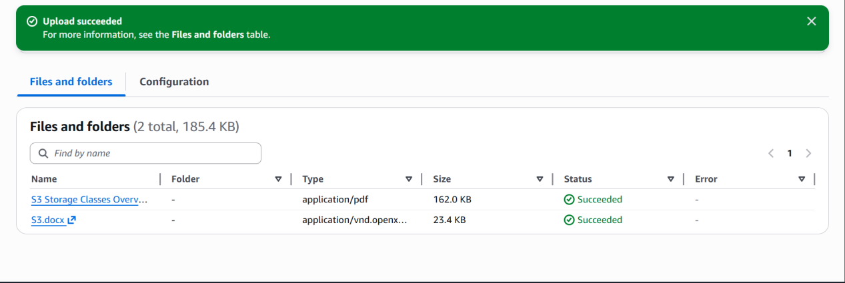

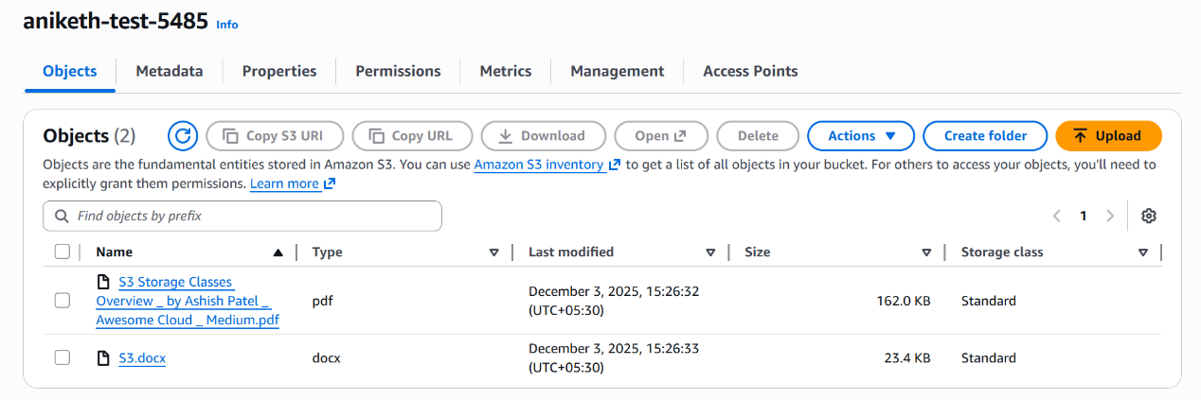

- Deploy a static website in the S3 bucket.

Step 1: Create an S3 Bucket**

1. Go to **AWS Console → S3**
2. Click **Create bucket**
3. Enter a unique bucket name (e.g., *my-static-site-123*)
4. **Region:** Choose one near you
5. **Uncheck**: "Block all public access"
6. Confirm that the bucket will become public
7. Click **Create bucket**

Step 2: Enable Static Website Hosting**

1. Open your newly created bucket
2. Go to **Properties** tab
3. Scroll to **Static website hosting**
4. Click **Edit** → Enable
5. Choose **Host a static website**
6. Specify:

* Index document: `index.html`
* Error document: `error.html` (optional)
7. Save changes
8. Note down the **Endpoint URL** — this is your website link.

Step 3: Upload Your Website Files**

1. Go to **Objects** tab
2. Click **Upload**
3. Upload all your static files (HTML/CSS/JS/images)
4. Click **Upload**

Step 4: Make Files Public**

To allow public access, you need to update permissions.

### **Option A — Bucket Policy (recommended)**

Go to **Permissions → Bucket policy** and paste this:

```json
{
"Version": "2012-10-17",
"Statement": [
{
"Effect": "Allow",
"Principal": "*",
"Action": "s3:GetObject",
"Resource": "arn:aws:s3:::YOUR_BUCKET_NAME/*"
}
]
}
```

Replace `YOUR_BUCKET_NAME` with your actual bucket name.
Save the policy.

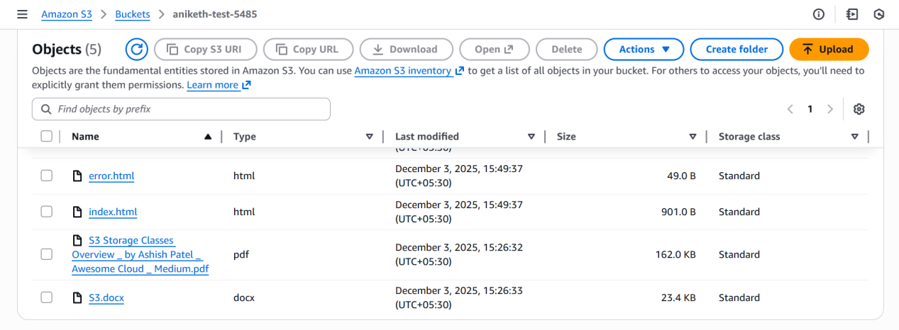

Step 5: Test Your Website**

Open the **S3 website endpoint**, which looks like:

```
http://YOUR_BUCKET_NAME.s3-website-YOUR-REGION.amazonaws.com
```

Your site should now load publicly.

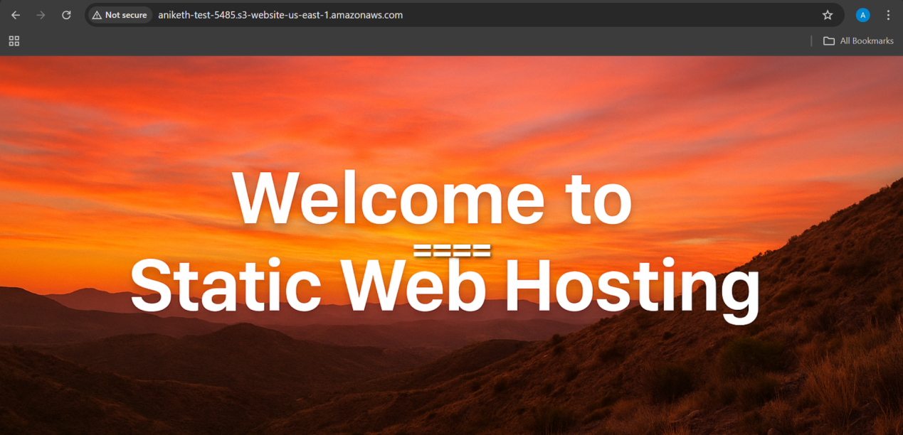

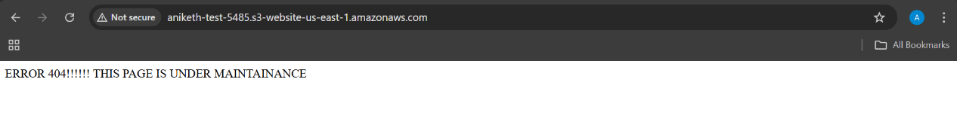

- Enable cross-region replication on S3 buckets.

Step 1. Open the AWS S3 Console**

1. Go to **AWS Console → Services → S3**
2. Select your **source bucket**

Step 2. Enable Versioning on Both Buckets**

### **Source bucket**

* Open the bucket
* Go to **Properties** tab
* Scroll to **Bucket Versioning**
* Click **Edit → Enable → Save changes**

### **Destination bucket**

Repeat the same steps on the destination bucket.

---

Step 3. Configure Replication Rule**

In the **source bucket**:

1. Go to the **Management** tab
2. Scroll down to **Replication rules**
3. Click **Create replication rule**

---

Step 4. Define Rule Settings**

* **Replication rule name:**
→ e.g., `replicate-to-ap-south-1`
* **Status:**
→ *Enabled*
* **Choose rule scope:**

* **Entire bucket** → replicates all objects
OR
* **Prefix or tag filters** → optional filters

---

Step 5. Choose Destination Bucket**

1. Click **Choose destination bucket**
2. Select your destination bucket
3. AWS may prompt you to **enable Bucket Versioning** (if not already enabled)

---

Step 6. Configure Permissions**

AWS offers two options:

### **Option A: Create a new IAM role (recommended)**

* Select **Create new role**
* AWS will automatically generate the required IAM replication role

### **Option B: Use existing role**

* Only if you already have a replication IAM role created

Step 7 . Validate Replication**

After adding a new object to the **source** bucket:

* Go to **destination bucket**
* Check if the file appears within seconds/minutes

Replication time depends on:

* Object size
* AWS region distance
* Current S3 replication load

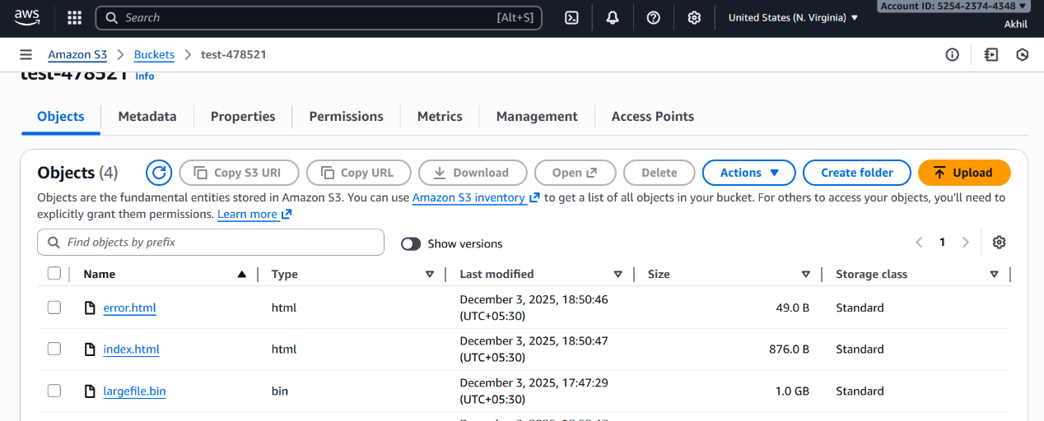

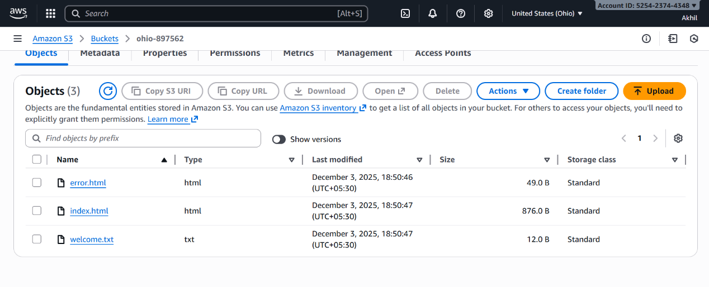

- Configure a bucket policy so only the Admin user can see the objects of the S3 bucket.

Step 1. Open the S3 Console**

1. Go to [https://console.aws.amazon.com/s3](https://console.aws.amazon.com/s3)
2. Select the bucket you want to restrict.

Step 2. Go to the Bucket Permissions Tab**

1. Click **Permissions**.
2. Scroll to **Bucket policy**.
3. Click **Edit**.

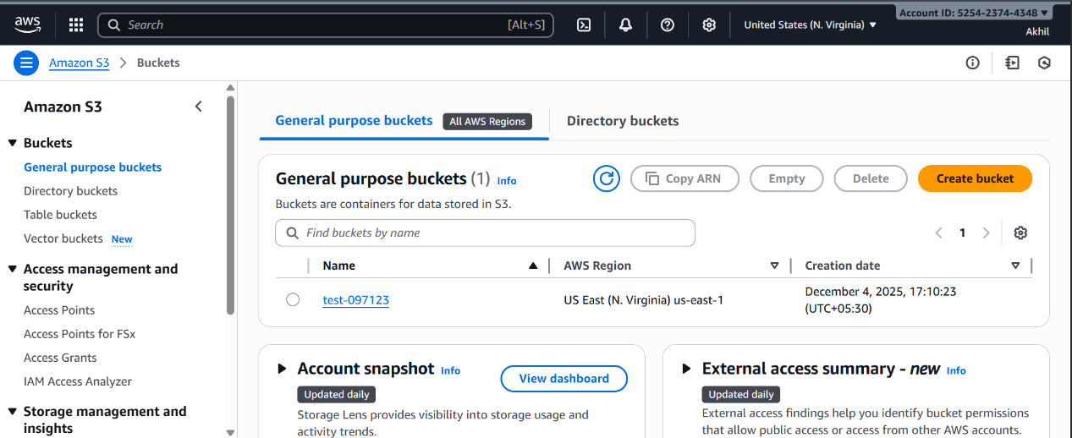

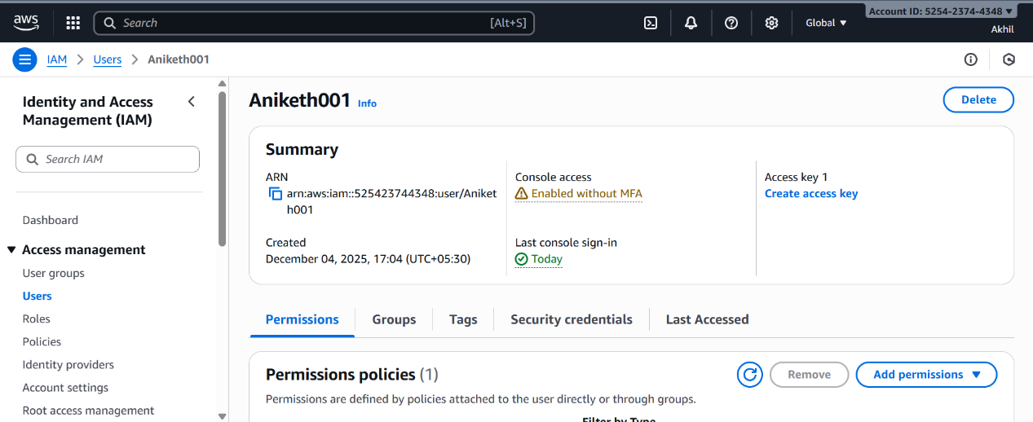

Step 3. Add a Policy Allowing Only the Admin User**

Replace the `Resource` bucket name and the IAM ARN with yours:

```json
{
"Version": "2012-10-17",
"Statement": [
{
"Sid": "AllowAdminUserOnly",
"Effect": "Allow",
"Principal": {
"AWS": "arn:aws:iam::ACCOUNT-ID:user/Admin"
},
"Action": [
"s3:GetObject",
"s3:ListBucket"
],
"Resource": [
"arn:aws:s3:::YOUR-BUCKET-NAME",
"arn:aws:s3:::YOUR-BUCKET-NAME/*"
]
}
]
}

Step 4. BLOCK ALL OTHER ACCESS**

make sure:

* **Block Public Access** is *enabled*
* No other IAM users, groups, or roles have S3 permissions for this bucket

Steps:

1. Under **Permissions → Block Public Access**
2. Make sure **all four options** are ON (enabled).

Step 5. Save the Policy**

Click **Save changes**.

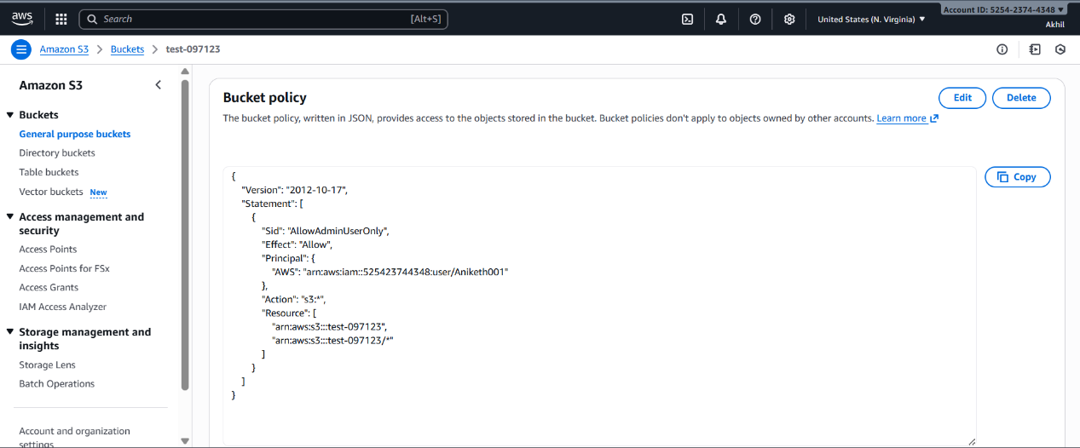

Final Behavior After This Policy**

* Only the IAM user **Admin** can:

* List the bucket
* View/download objects
* No other user / role / service can access the bucket unless explicitly allowed.

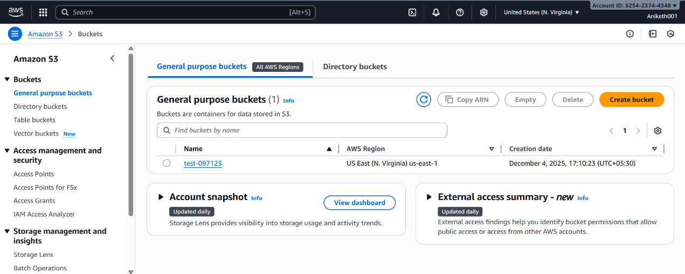

- Set up lifecycle policies to automatically transition or delete objects based on specific criteria.

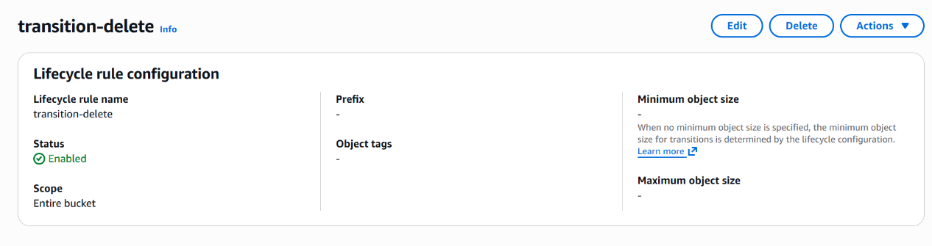

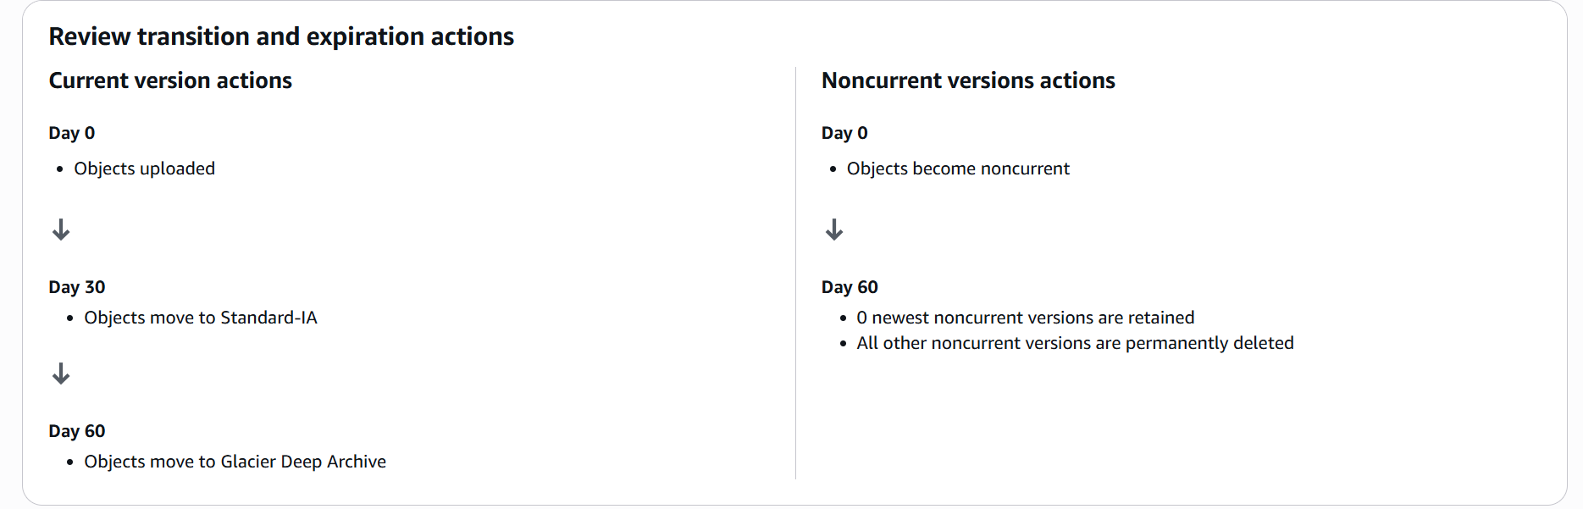

- Push some objects to S3 using the AWS CLI.

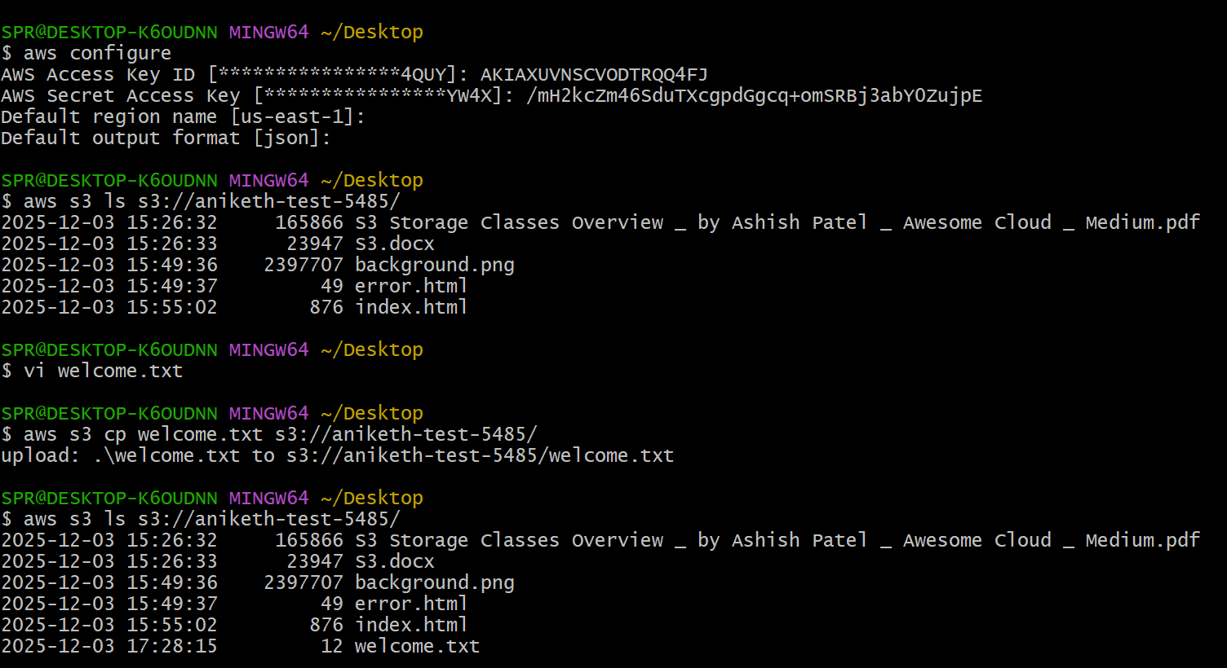

- Write a Bash script to create an S3 bucket.

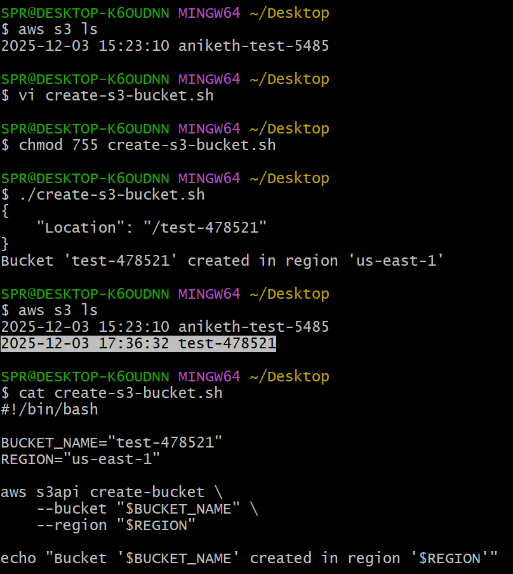

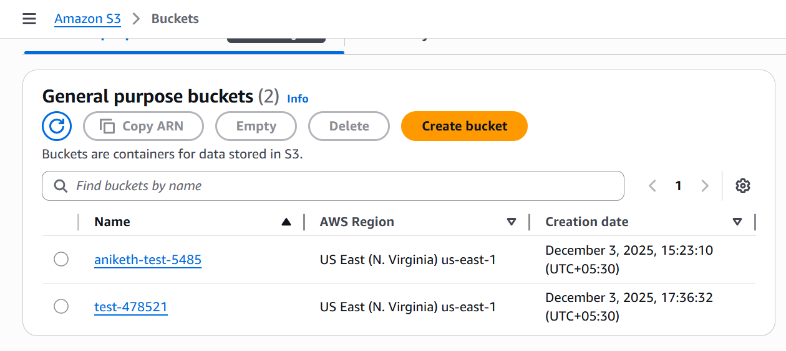

- Upload a 1 GB file to S3 using the CLI.

dd if=/dev/zero of=myfile_1gb.bin bs=1M count=1024

→ generates 1 GB of zero-filled data

aws s3 cp largefile.bin s3://test-478521/

This command uploads the file in the target bucket mentioned.

